Project Report

Aim: The main aim of this project is to reduce human resources and efforts along with the enhancement of a smarty city SMART DUSTBIN

Abstract: The main objective of the project is to design a smart dustbin which will help in keeping our environment clean and also eco friendly. Now a days technologies are getting smarter day-by-day so, as to clean the environment we are designing a smart dustbin by using Arduninouno , along with ultrasonic sensor, servo motor, and battery jumper wire.

Problem definition: some people are so careless to through the garbage in the dustbin by opening the lid

Problem solution: for this case these smart dustbin is helpful to open the lid of the dustbin automatically.

Working:

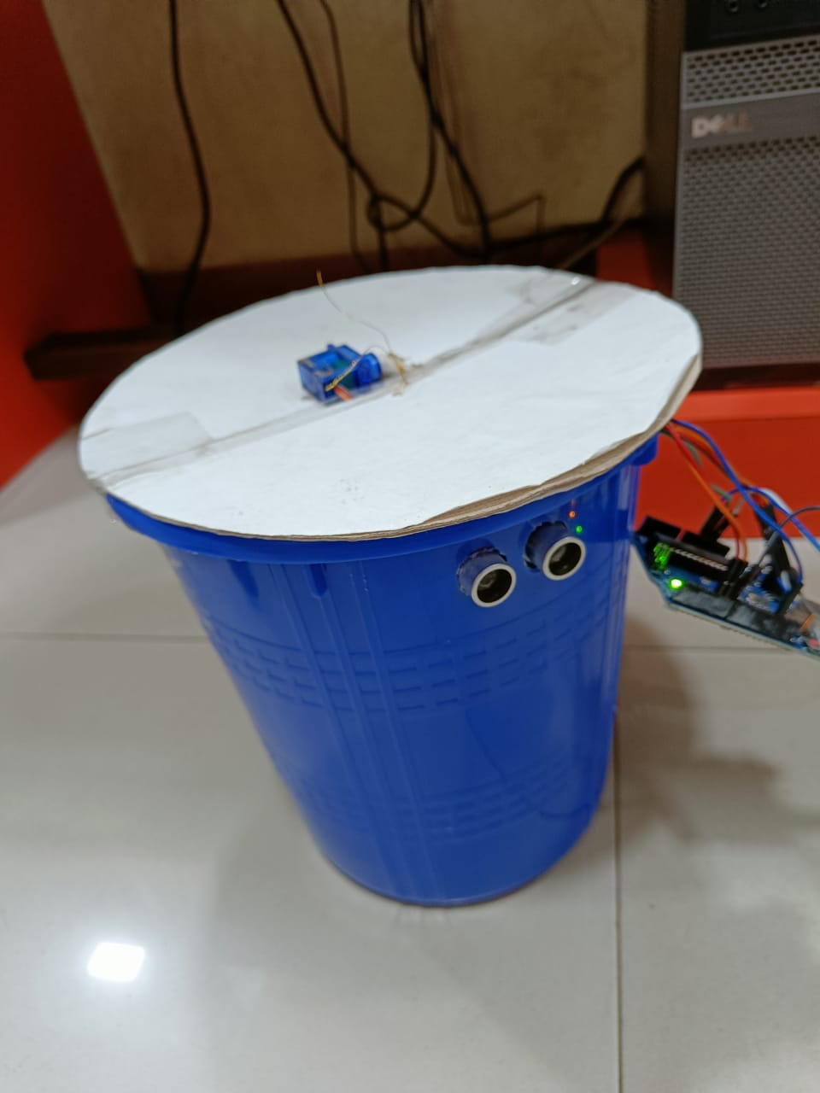

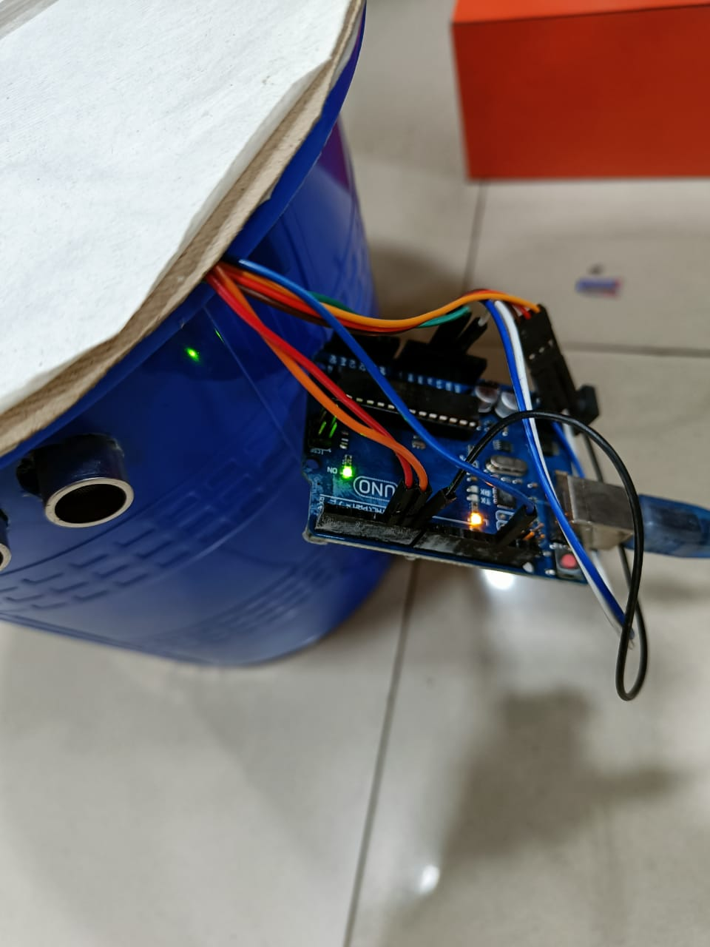

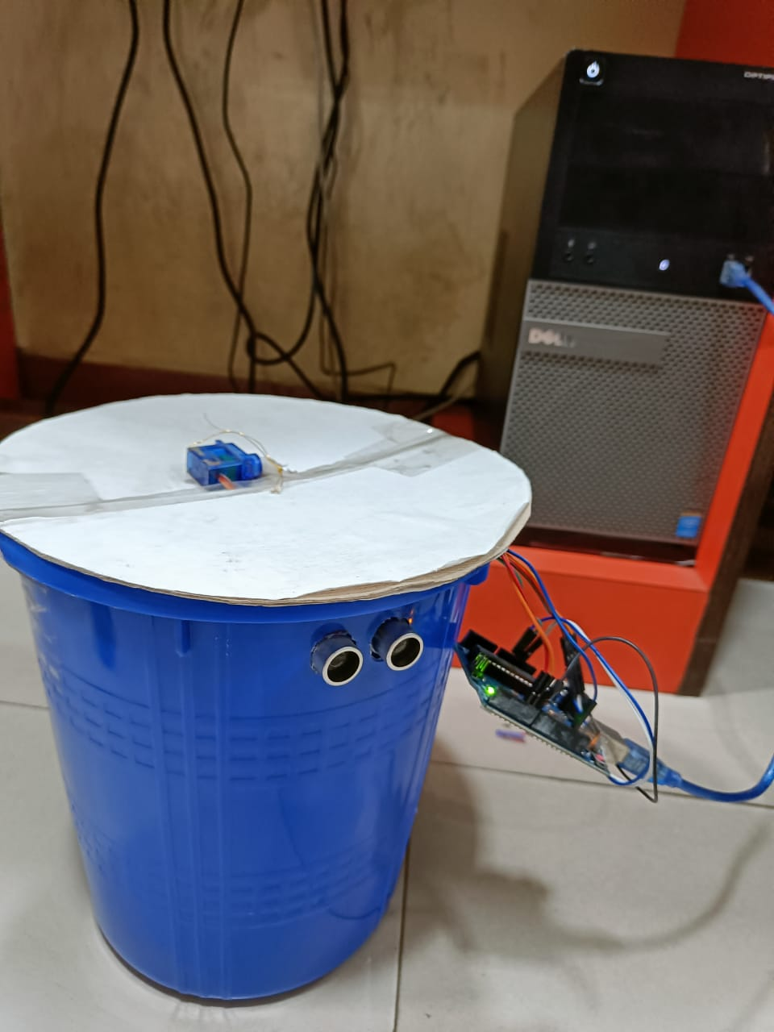

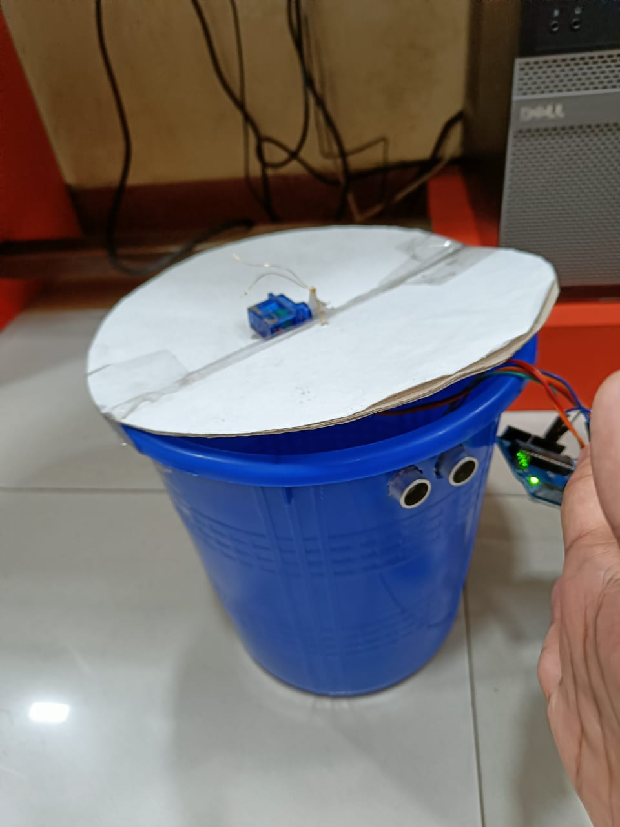

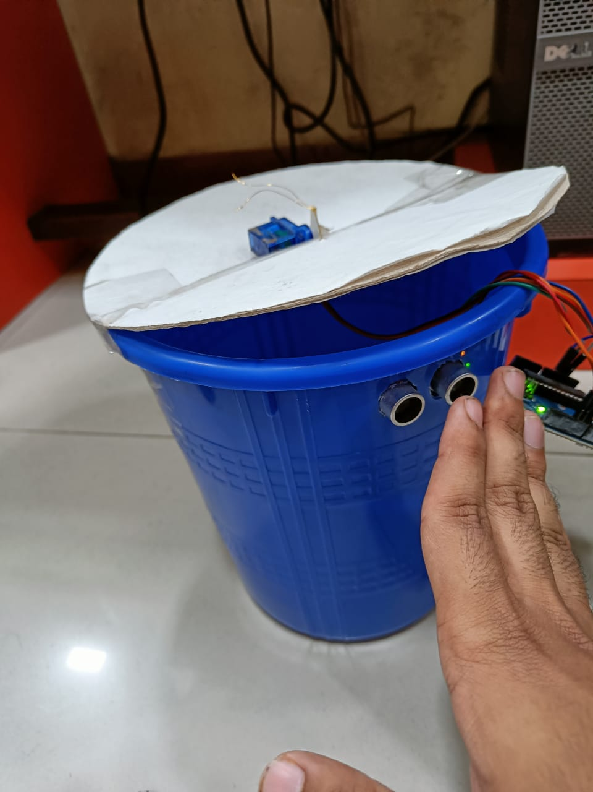

Conclusion: A simple but useful project called smart dustbin to open the lid automatically.